OFFICE SAFETY
The office can be as dangerous as any other work environment. The potential exists for cuts, burns, slips, trips and falls, crushing injuries, repetitive motion syndrome, eyestrain and other injuries. The following safety practices apply to any office setting:
- Furniture with sharp corners, projecting edges or wobbly legs should be reported so they can be repaired or replaced.
- Tilting chairs should be used properly and well maintained to prevent tipping.
- Chairs, desks, tables or other furniture should not be used in lieu of a ladder.
- File, desk and table drawers should be closed when not in use to avoid tripping or striking injuries.
- Only one file drawer should be opened at a time and never left open.
- The top drawer of a file cabinet should be less filled and heavy than other drawers.
- Close file drawers slowly to avoid pinching fingers.
- Blades of paper cutters should be closed when not in use.
- Hands should be kept clear of printer and typewriter carriages.
- Paper cuts can be minimized by use of rubber finger guards and sponges for moistening.
- Scissors, paperclips, thumbtacks, razorblades, etc. should be stored and used cautiously.
- Floors and walkway surfaces must be kept clean, dry and unobstructed.
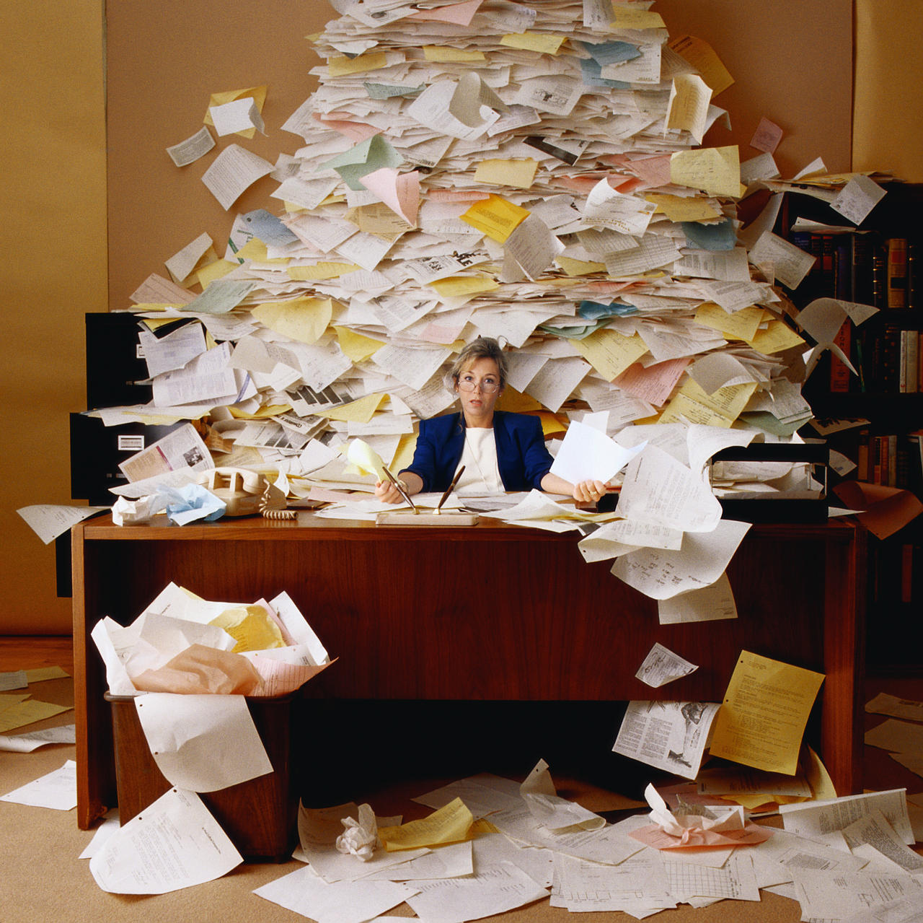
- Stored or stacked objects must not be placed where they are hard to reach or where they might fall.
- Office "avalanches" can result from faulty stacking of heavy boxes, papers, books and other office materials above your head on the top shelf.
- Hallways, stairs and lobbies shall not be used for storage of any kind.
- Replace all frayed wiring, improper grounding and malfunctioning electrical equipment.
- Keep an eye open for telephone, extension and electrical cords, loose carpeting, and objects that might cause a trip and fall.
For a safe work place, report, repair and replace all potential hazards.

