Health, Safety and Environment

Lessons Learned
Excavation Fatality
Subject | Fatality – Excavation Collapse
Situation | 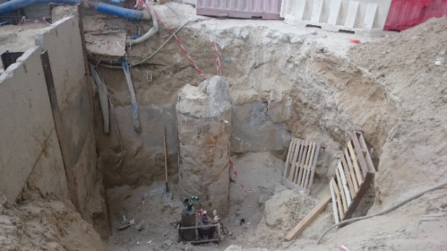  Two prime contractors were undertaking concurrent construction activities on the project. Five workers from one of the contractors were working on a public holiday weekend, without authorization from the Client, Project Managers or Supervision Consultant. The group were also assigned to work by the contractor’s engineer in charge without any supervision.  In order to work on the previously cast pile the workers had excavated material and placed the spoil on the excavation edge.  The deceased, a welder, was working inside the excavation cutting the pile casing, whilst his colleagues had gone for breakfast outside the work area leaving him working alone.  Whilst the welder was working, spoil from the excavation edge collapsed crushing his torso against the pile, causing compressive asphyxia. His co-workers returned twenty minutes later and found him unresponsive.
Lessons Learned | A lack of effective planning and management resulted in workers being assigned to work with without supervision and in an unsafe environment.
Recommendation/ Comment | Contractor was removed from the project.  Contractors need to be advised that any work during non-working days (weekend / public holidays / night work) should be notified to the client / consultant for approval. As a proactive measure, the supervision consultant should issue a reminder to contractors prior to public holidays.  All works must be supervised, and include adequate first aid cover.  Without risk assessment and control measures, lone working must not be permitted.  A cubic meter (m3) of soil or sand can weigh between 1.2 -1.7 Tonnes, therefore, excavated material should be placed away from the excavation edge in accordance with local regulations. Excavations must also be adequately protected / supported. Reference SOP-307 Excavation and Trenching Safety for more information.  Where there are potentially complicated arrangements i.e. two prime contractors on the same site, this should be discussed with all stakeholders and specific control measures implemented.
Date submitted: | November 3 2016
Submitted by: | Aziz Zerban / Dave Lochlin
To submit a Lessons Learned contact:
Jeannie Armstrong:
jeannie.armstrong@ch2m.com
T +1 425.233.3071 x25071

