Toolbox Talks

WINTER SAFETY – EMERGENCY PREPAREDNESS WHILE DRIVING

What Should You Do If You Start To Skid?

- Above all don’t panic! | 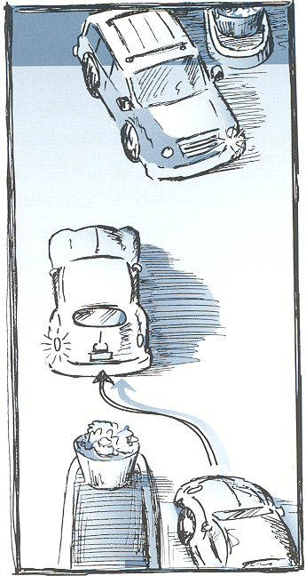
- Look where you want your vehicle to go and steer in this direction.
- Do not brake!
- Do not accelerate!
- Disconnect the driving force on the drive wheels by doing either of the following:
  - Automatic Transmission - Shift to neutral.
  - Manual Transmission - De-clutch.
How to Brake on a Slippery Road (Without Anti-Lock Brakes)
If the emergency does not require slamming the brakes as hard as possible, squeeze braking (threshold braking) along with declutching (or shifting to neutral in an automatic) will do the job most efficiently
- Use the heel-and-toe method. Keep your heel on the floor and use your toes to press the brake pedal firmly just short of locking up the wheels.
- Release the pressure on the pedal, and press again in the same way.
- Repeat this until you come to a full stop.

How to Avoid Being Rear-Ended

A lot of rear-enders happen while you are stopped at an intersection with your foot on the brake. The driver behind you sees that you’re stopped and sees your brake lights, so he comes to a stop behind you.

Then you start to pull ahead and the guy behind you thinks its time to go and hits the gas. The only problem is that you immediately have to slam on the brake because:
- You see someone who looks like they’re running the red light.
- A pedestrian runs in front of you. Etc. etc. etc.
When you apply the brakes again, the car behind you isn’t paying attention and he hits you, because he saw your brake lights go off and saw you move forward.

To avoid this in the future, when you want to pull ahead a little at an intersection, just ease up on the brake enough to let the car creep forward, but don’t take your foot completely off the pedal. That way your brake lights stay on and you won’t mislead the fellow behind you.

CREWMEMBER SAFETY TOPIC

