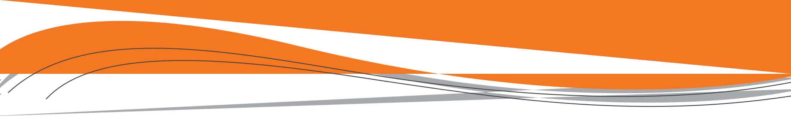
Backing vehicles

Explain dangers

Every year, workers are killed and injured by backing vehicles and machinery. If you work in the homebuilding, ICI, heavy civil, or road building industry, you have an increased likelihood of getting struck by heavy equipment.

The main problem is blind spots around heavy equipment. If you’re in a blind spot and the operator doesn’t know you’re there, you could be backed over.

The hazards increase in congested areas where vehicles and heavy equipment are backing up all the time. Noise distracts people and dust makes it difficult to see and be seen.

- Make eye contact with the driver or operator before you signal or change position.

- Do not perform any other duties. Signalling requires your full concentration.

- Know driver and operator blind spots.

[Show your crew these diagrams of blind spots.]

Identify controls

You can plan a drive-through site to limit the need for backing up. But on most projects, trucks and equipment have to operate in reverse at some point. That’s when a signaller is necessary.

The signaller is another pair of eyes for the driver. If you’re asked to work as a signaller, follow these tips.

- Wear high-visibility clothing as required.

- Stand where the operator can see you at all times, and where you have a full view of the intended path of travel. You must, however, stay out of the vehicle’s path.

- Use the hand signals demonstrated below.

Traffic Control Hand Signals
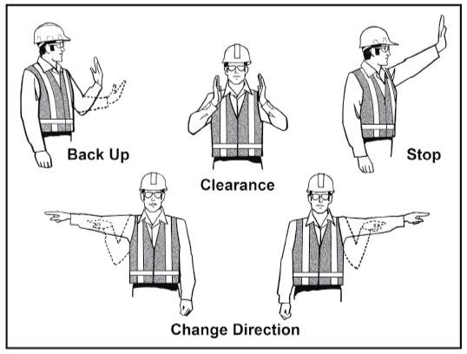

Make eye contact with the operator before approaching vehicles and equipment.

NOTE: You can use new technology such as a system that can read tags on worker’s vests or hard hats and send a signal to warn the operator that someone is behind the vehicle. But systems like this may not be available on most projects.

Demonstrate

Show your crew where the blind spots are on a truck or piece of heavy equipment on site. Get them to see things from the operator’s perspective.

Vehicles | 47


