
Lift trucks in the warehouse
Explain dangers

Many workers are injured by lift trucks in situations like the following.

- A lift truck is unintentionally driven off a loading dock.

- A lift truck falls between a dock and an unsecured trailer.

- A worker is struck by a lift truck when it is backing up or when the worker cannot be seen by the operator.

- A lift truck tips over and crushes the operator or a worker.

- The load on a lift truck falls off the forks because it was not loaded or secured properly.

- The operator did not keep his or her hands and feet inside the cab.

- The operator slips or falls when getting in or out of the cab.

Many incidents also involve property damage including damage to overhead sprinklers, racking, pipes, walls, and machinery.

Most injuries and property damage are caused by

- lack of safe operating procedures

- lack of safety rule enforcement

- insufficient or inadequate training.

Identify controls

- Always wear suitable clothing and safety shoes or boots when you are working in a warehouse.

- Always fasten your seatbelt when driving a lift truck.

- Always use 3-point contact when getting in and out of the cab.

- Take off any jewellery, and keep long hair tied back to prevent it from being caught in machinery or equipment.

- Watch out for other workers and vehicles, especially near doorways and ends of aisles.

- When backing up, always look in the direction that you are travelling. Watch for people, equipment, or anything else in your path of travel.

- Don’t be afraid to use your horn. It’s better to make too much noise than not enough.

- Secure the load properly to prevent it from falling onto equipment or pedestrians.

- When you are stacking something on high shelves, make sure the lift truck can stack at the proper heights and manoeuvre in aisles without becoming unstable.

- Review the manufacturer’s instructions and keep the manual with the equipment for quick reference.
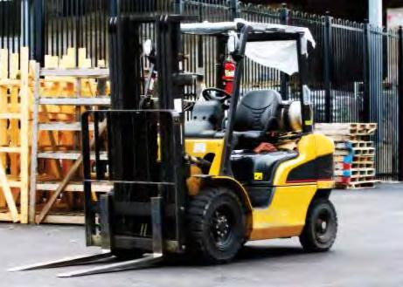

Demonstrate

- Ask the crew to show that they understand the load chart.

- Ask lift truck operators if they can remember the speed limits and warning signs at your facility.

- Ask the operators to show that they understand all the warnings and precautions for the type of lift truck they will be allowed to use.

₅₄  Vehicles

