Safe setup of heavy equipment
Explain dangers

The use of concrete pumps and boom trucks is common on most residential sites. In addition to increased productivity, there are ergonomic and safety-related benefits. However, if the site is not set up properly, concrete pumps and boom trucks can be dangerous for the equipment operator as well as for other workers nearby.

- The concrete pump, concrete delivery truck, or boom truck may block the path of emergency vehicles.

- The pump or truck may tip over.

- The boom may come in contact with a powerline.

- Workers may be injured by concrete delivery trucks that are backing up.

Identify controls

Proper site planning can prevent many of these problems.

- The Occupational Health and Safety Act requires every project to have written procedures to follow in case of an emergency. If part of the site is blocked off, emergency vehicles and personnel may not be able to reach injured workers.

Make a proper staging area by grading driveways or other areas off the road. That will give concrete pumps, boom trucks, and other heavy equipment enough space to set up properly off the road so they won’t block traffic.
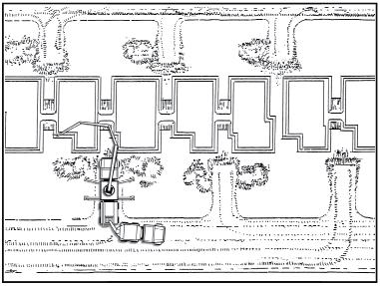

- To ensure the stability of the concrete pump or boom truck, the ground where the equipment is set up has to be level and compacted. Refer to CSA Z151-09—Concrete Pumps and Placing Booms and the manufacturer’s instructions.

- To prevent the boom from contacting overhead powerlines, follow the procedures below.

  - Establish written procedures to ensure that equipment or loads do not encroach on minimum distances to powerlines.

  - Provide adequate devices that are visible to the operator to warn of electrical hazards.

  - Station a signaller in full view of the operator to warn them each time the equipment may approach the minimum distance.


NOTE: Refer to sections 188 and 189 of the Regulation for Construction Projects (213/91).

4. Concrete delivery trucks need to back up to

fill the pump hopper. Always have a designated

signaller in place to keep anyone from being

hit by a reversing vehicle. Regulations require that a signaller wear high-visibility clothing and use pre-arranged hand signals to communicate with the operator (O. Reg. 213/91, s.104 and 106).

Traffic Control Hand Signals
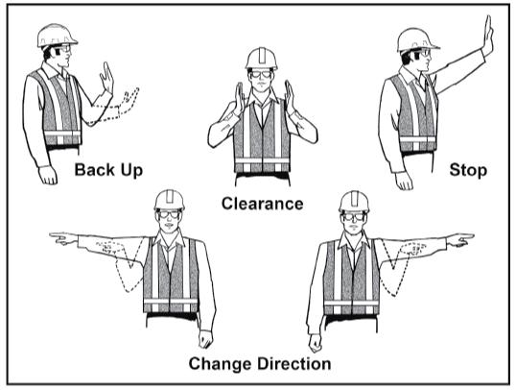

Demonstrate
Review the site plan and staging areas with those
involved. This will ensure that concrete pumps and
boom trucks will be set up correctly.
Example of Proper Site Setup
53

