Slip and fall hazards for truck drivers

Over a five-year period, slips and falls were the cause of nearly 50 per cent of all critical injuries in the trucking industry.

Explain dangers

Pay special attention when working on the following surfaces:

- ramps and gang planks without skid- or slip-resistant surfaces

- metal surfaces such as dock boards and dock plates, platforms, construction plates or covers on sidewalks, and roads

- metal rungs, steps, footholds, treads, running boards, and platforms on equipment and ladders.

Remember: metal is slippery because of its lower force of friction and traction. Metal surfaces such as running boards can become smooth and slippery with wear and extremely slick when wet, muddy, oily, dirty, or greasy.

Identify controls

When working around flatbed trucks:

- Clean footwear of mud, snow, ice, grease, or other slippery substances.

- Make sure running boards, treads, steps, footholds, and platforms are clean and dry.

- Always face equipment when mounting and dismounting.

- Have a secure grip on the handhold before stepping up.

- Place your foot firmly on the step or foothold so that it’s in front of your heel, under the arc of your foot

- Always be aware of your surroundings and any obstacles around you.

- Don’t climb down with something in your free hand. Put it on the floor of the vehicle and reach for it when you get down to the ground

The single biggest cause of falls from a vehicle is driver error and failure to follow the 3-point contact rule.

When mounting and dismounting:
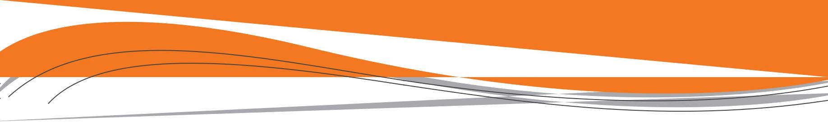

- Maintain 3-point contact while getting onto or off of the equipment until you reach the ground, cab, or a stable platform. This means one hand and two feet or two hands and one foot must be on the equipment at all times.
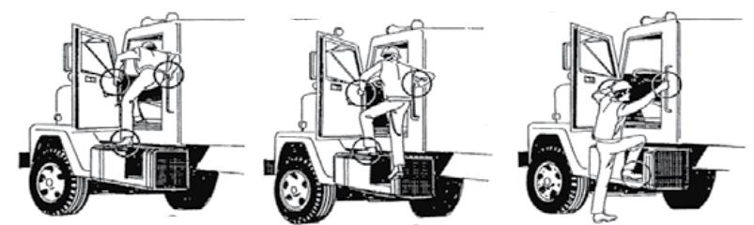

- Do not jump down when getting off the bed of a truck or other part of the equipment. Step down carefully while facing the equipment.

To prevent slips and trips:

- Wear shoes with good support—not sandals, bare feet or high heels.

- Exit and enter facing the cab.

- Slow down and use extra caution in bad weather.

- Get a firm grip on rails and handles with your hands.

- Look for obstacles on the ground before exiting.

- Don’t rush to climb out after a long run. Descend slowly to avoid pulling a muscle.

- Don’t ever jump out. You may land off balance or on an uneven surface and fall.

- Don’t use tires or wheel hubs as a step surface.

- Don’t use unauthorized handholds such as door frames or door edges.

Demonstrate

Demonstrate 3-point contact to your workers by properly mounting and dismounting a vehicle.

Vehicles | 55


