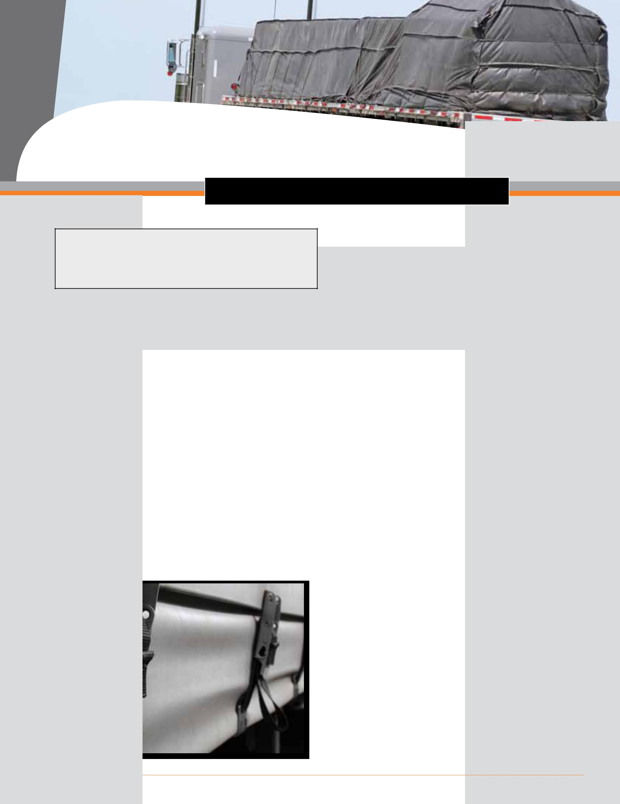

SafetyTalk
Tarping loads on a flatbed trailer

A flatbed driver was covering a load of steel with a large tarp. While pulling hard on the tarp to unfold it, he felt a sudden pain in his right shoulder. This injury resulted in extensive therapy and several days off work.

Explain dangers

Covering a load with tarps and removing them afterwards can be hard work for flatbed truck drivers. A tarp can weigh up to 100 pounds and be difficult to handle, especially if the load you’re covering is bulky or uneven or if the weather is windy, wet, or icy.

Tarping a load manually can put a driver at risk of:

- Falling from heights while climbing on top of the load

- Slipping or tripping on the tarp or straps

- Developing a musculoskeletal disorder (MSD) in the back, neck, shoulders, muscles, or joints from lifting and pulling, bending and reaching, overexertion, and working in awkward positions.

Identify controls

- If possible, do not climb on top of the load to spread the tarp manually. Instead, use equipment such as:

  - An overhead tarping system that lifts and spreads the tarp manually over the load

  - A forklift that places the tarp on top of the load.

- If you have to climb on top of the load to spread the tarp manually, never stand up or walk around. Crawl on your hands and knees instead. If possible, use a fall arrest system in a dedicated tarping area.

- Get help from other workers and plan the lift together.

- Use small, light tarps instead of large, heavy ones. It takes less physical exertion to cover a load with three small tarps than with two large ones.

- Learn proper tarping techniques such as where to place and unfold the tarp, how to tuck in the folds, where to connect the bungee cords, etc.

- Use a detachable ladder with handles or fold-out steps to get on and off trailers.

- Maintain 3-point contact when getting on and off trailers.

- Climb on and off the flatbed from the back of the trailer or the catwalk. Don’t jump down.

- When weather conditions are windy, park the flatbed close to a building to block the wind and prevent the tarps from blowing around as much.

- Stand with your legs spread apart for balance before pulling the tarp.

- Get a firm grip on the tarp. Do not just hold the ropes—they can slip or break.

- Use both hands to pull the tarp in order to prevent overexertion.

- Keep your hands close to your body at about waist height to prevent overreaching.

- Wear non-slip gloves to maintain your grip.

- Wear footwear that is appropriate for the weather conditions.

Demonstrate

- Demonstrate the proper tarping techniques with the crew.

- Ask them to describe any problems they have had with tarping loads.

2 ihsa.ca

